**Why do some biomes produce more food than others?**

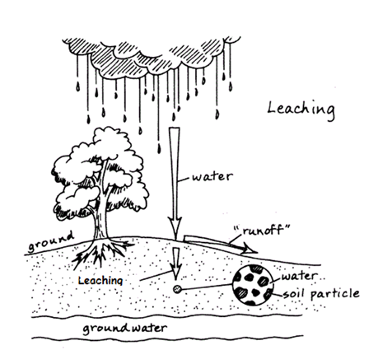**Leaching**

What human activity also affects nutrient depletion of the soil? Explain how this process works.

Farming – when farmers clear land they expose the soil to the harsh sun and heavy rain. This creates greater leaching of nutrients and further depletes the nutrients in the soil.

**Where our food comes from (page 58-59)**

1. What did you eat for breakfast/morning tea/lunch today?
2. What countries do you think you have eaten food from so far today?
3. Explain why people in Australia might have difficulty knowing where their food comes from.
4. Explain why people in Africa are more likely to know where their food is coming from.
5. Identify the main factor that would influence farmers about the crops they would choose to grow or animals to raise.
6. Identify which major supermarket sells more Australian produce.
7. Examine Source 1.23 and identify which areas of Australia are more suitable for agriculture.
8. In which states of Australia is there less agriculture?

**The importance of climate:**

Read P 62 and look carefully at source 1.27.

1. What climate does Innisfail have?
2. How does this impact on the types of crops that are farmed in this area?
3. Identify two factors that influence the type of farming conducted in a particular location.
4. In drier locations, what kind of farming would be more successful?
5. What problems could occur as a result of large areas of the Earth’s surface being farmed the same way?
6. Explain three ways farmers can use technology to overcome the limitations of climate.
7. According to source 1.28, is Australia more livestock or agriculture dominate?

**The importance of Soil**

Read P64-65 and answer the following questions.

1. Identify the components that make up soil.

Air, broken down rock, water and organic material

1. Explain why soil is so important.

It feeds every animal on earth

1. Complete the following table of how rocks break down:

|  |  |
| --- | --- |
|  | Explain the impact of this on Rocks |
| Weathering | Braking into smaller rocks |
| Chemical changes |  |
| Water | Dissolves minerals in rock |
| Oxygen | Combines with some minerals and wear them down slightly |

1. Explain the process of how plants grown in soil.

Seeds in the soil are exposed to water and using the nutrients from the seed sprout both roots and a stem. These roots and leaves then extract nutrients like water and various minerals in the soil

1. Explain what a horizon is in relation to soil.

A soil horizon is a layer of earth used describe the properties of it like the organic matter contents and rock size

1. How could knowing the horizon of soil be useful to farmers?

It tells them where the soil fit for growing plants is vertically

1. Is it possible for soil to have all horizons? Is it possible for soil to only have some horizons?

A horizon describes a section of soil, in one point that can only have one horizon. But at different depths all soil has different horizons

1. Explain why Australia’s soils are generally low in nutrients.

Most of Australia is desert which means because of the lack of water plants do not grow and fertilize the soil with their organic matter. Because Australia is so old this also means that most of the minerals in the soil have been washed away.

1. How can farmers improve the nutrient level of the soil?

Grow different plants, irrigate the plants and use external fertilizes

1. Is soil a renewable or non-renewable resource, explain your answer.

It seems non-renewable but it is in a very high supply. This is because soil takes a very long time to generate

1. After reading the paragraphs on page 65, bullet the major challenges Australian farmers face regarding soil condition.

Most of Australian soil is composed of clay making it hard for the plant roots to penetrate the ground.

1. Describe the process of the development of soil horizons over time.

The bedrock becomes more and more fractured until it turns into arable soil